Razor Markup

Razor is a simple markup syntax for embedding server code (C# or VB) into ASP.NET web pages

Razor Syntax for C#

C# code blocks are enclosed in @{ ... }

Inline expressions (variables or functions) start with @

Code statements end with semicolon

Variables are declared with the var keyword, or the datatype (int, string, etc.)

Strings are enclosed with quotation marks

C# code is case sensitive

C# files have the extension .cshtml

<!-- Single statement block -->

@{ var myMessage = "Hello World"; }

<!-- Inline expression or variable -->

<p>The value of myMessage is: @myMessage</p>

<!-- Multi-statement block -->

@{

var greeting = "Welcome to our site!";

var weekDay = DateTime.Now.DayOfWeek;

var greetingMessage = greeting + " Today is: " + weekDay;

}

<p>The greeting is: @greetingMessage</p>

@RenderPage

<html>

<body>

@RenderPage("header.cshtml")

<h1>Hello Web Pages</h1>

<p>This is a paragraph</p>

@RenderPage("footer.cshtml")

</body>

</html>

Preventing Files from Being Browsed

With ASP.NET, files with a name that starts with an underscore cannot be browsed from the web.

Hiding Sensitive Information

With ASP.NET, the common way to hide sensitive information (database passwords, email passwords, etc.) is to keep the information in a separate file named "_AppStart".

# MVC:

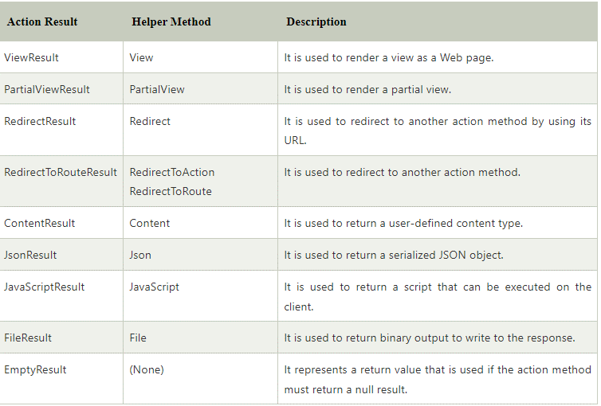

# **MVC Action Selectors**

## **ActionName**

This attribute allows us to specify a different name for the action method. It is useful when we want to call action by different name.

## **ActionVerbs**

ASP.NET MVC provides action verbs that are applied on the action methods and works for HttpRequest methods. There are various ActionVerbs and listed below.

* HttpPost
* HttpGet
* HttpPut
* HttpDelete
* HttpOptions
* HttpPatch

ActionVerbs are name of the http requests that a controller handle. We can use it for selection among the action methods.

# **ASP.NET MVC Action Filters**

The MVC framework provides the filter attribute so that we can filter the user requests.

**OutputCache:** it makes controller's action output cacheable for the specified time.

**HandleError:** It is used to handle error raised when a controller action executes.

# **Input Validation**

